My Weekend
Class６―
Name:
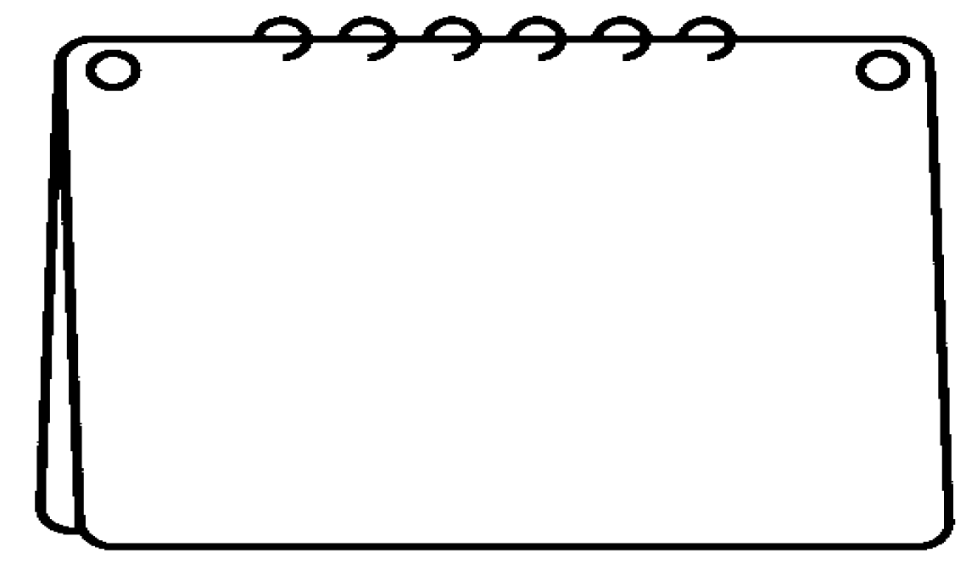

It was .

I went to .

I enjoyed .

My Weekend
Class６―
Name:

